CVOCD-X Programmable MIDI-to-CV Interface
CVOCD-X builds on the CV.OCD programmable MIDI-to-CV interface and its companion Gate Boost module. With CVOCD-X you get four CV outputs (0-8V range) and twelve gate outputs (5,10 or 15V level) on 4mm banana sockets, plus a ground socket. Outputs can be freely assigned to a multitude of MIDI events and controllers using the web-based configuration tool. Find out more at six4pix.com/cvocdx. The diagram below shows the features of your CVOCD-X

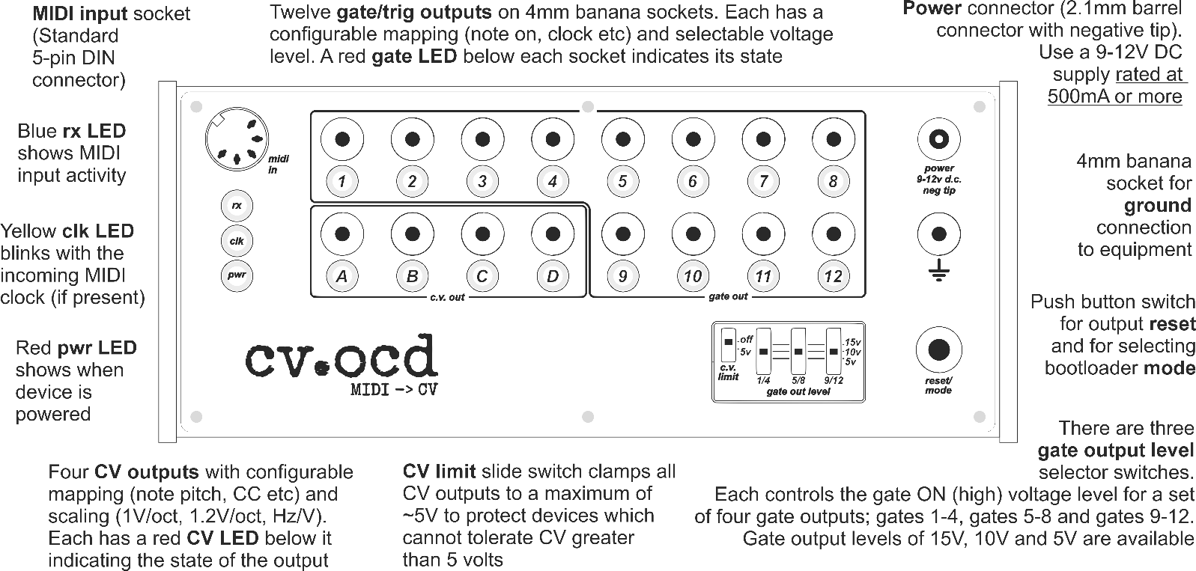

Each new CVOCD-X is configured with the following default mappings from its MIDI input to its CV and gate outputs. You can, of course, change this configuration using the web configurator, which you can find via the web page six4pix.com/cvocdx
Gate 1  Chan 1 Note Gate | Gate 2  Chan 1 Note Trig | Gate 3  Chan 2 Note Gate | Gate 4  Chan 2 Note Trig | Gate 5  Chan 10 Note C4  Gate | Gate 6  Chan 10 Note D4 Gate | Gate 7  Chan 10 Note E4 Gate | Gate 8  Chan 10 Note F4 Gate
CV A  Chan 1 Note Pitch (1.2V/Oct scaling) | CV B  Chan 1 Note Velocity  (5V scaling) | CV C  Chan 2 Note Pitch (1.2V/Oct scaling) | CV D  Chan 2 Note Velocity  (5V scaling) | Gate 9  Chan 10 Accent  Gate | Gate 10  1/4 Note Clock Out | Gate 11  1/8 Note Clock Out | Gate 12  1/16 Note Clock Out

Thank you for purchasing this product! I hope you find it useful and enjoy using it. You can download the full manual from six4pix.com/cvocdx. Contact me for questions or feedback at jason@six4pix.com
Cheers,
Jason
CVOCD-X is and designed and hand-assembled by Sixty-Four Pixels Ltd in Brighton, UK.
Thanks to Kai Niggeman and Signal Sounds

